TDL CNN ASSIGNMNET :
NAME : Sushma V
SRN : PES1UG23CS621
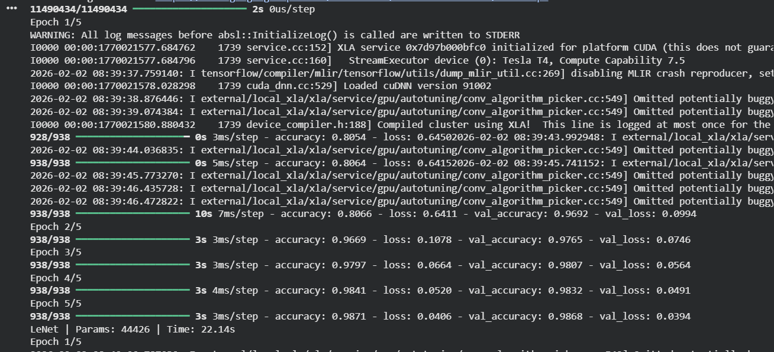

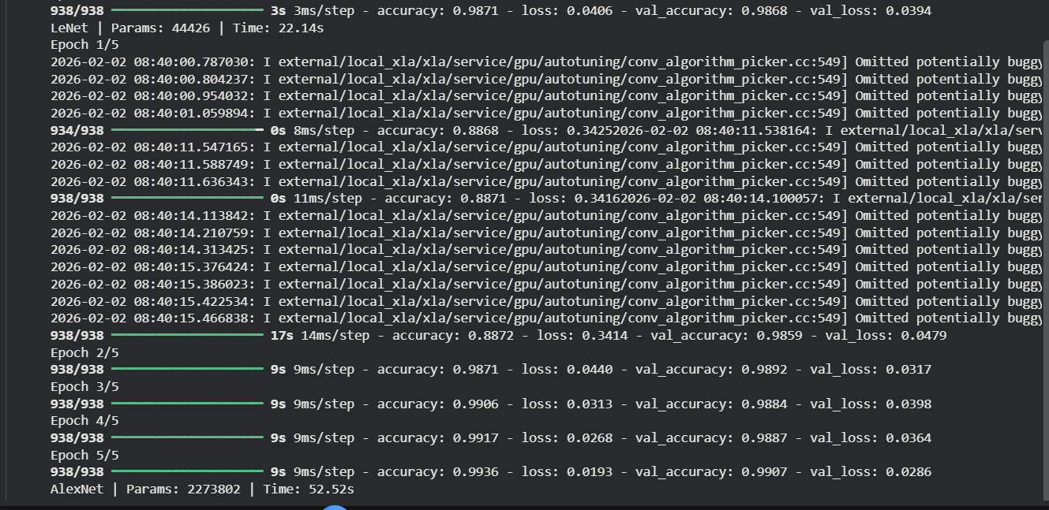
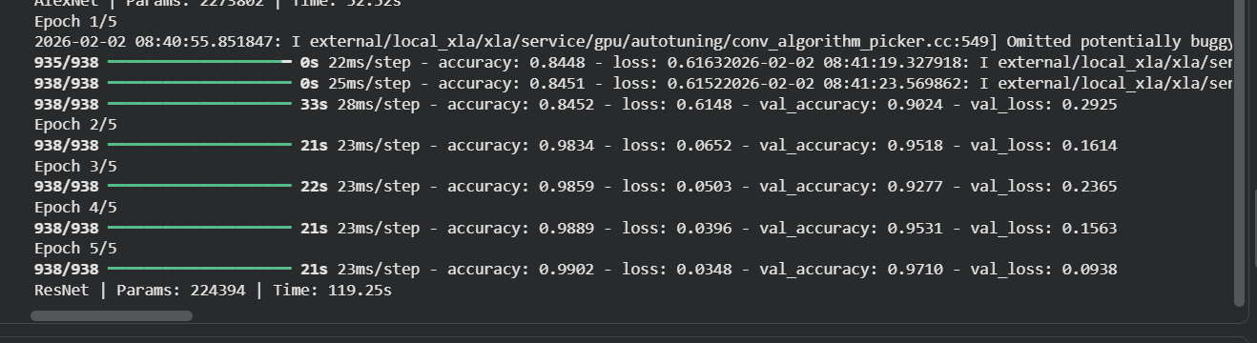

cifar10
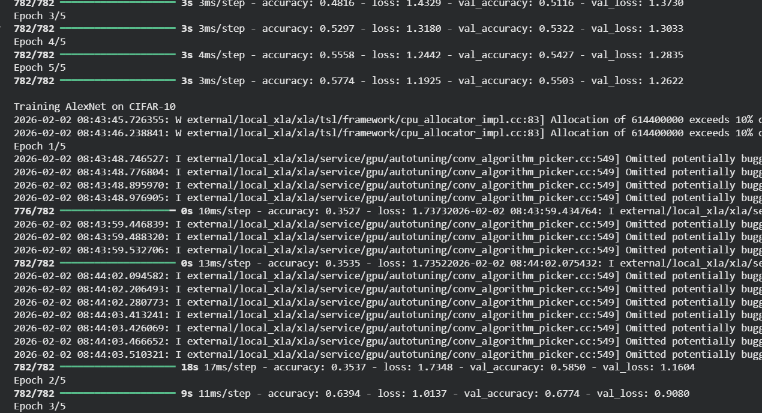
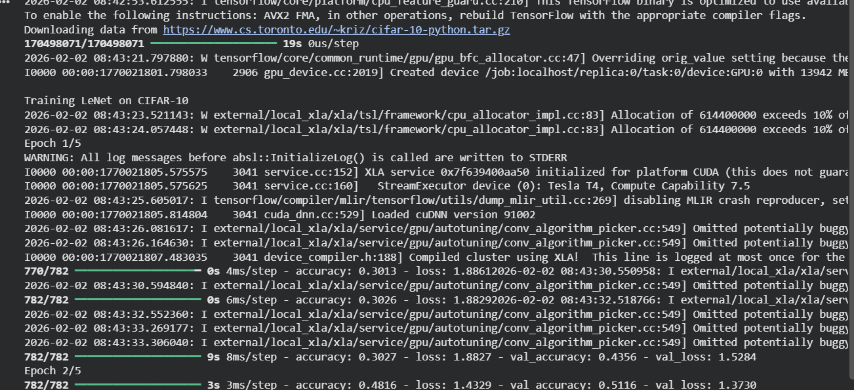

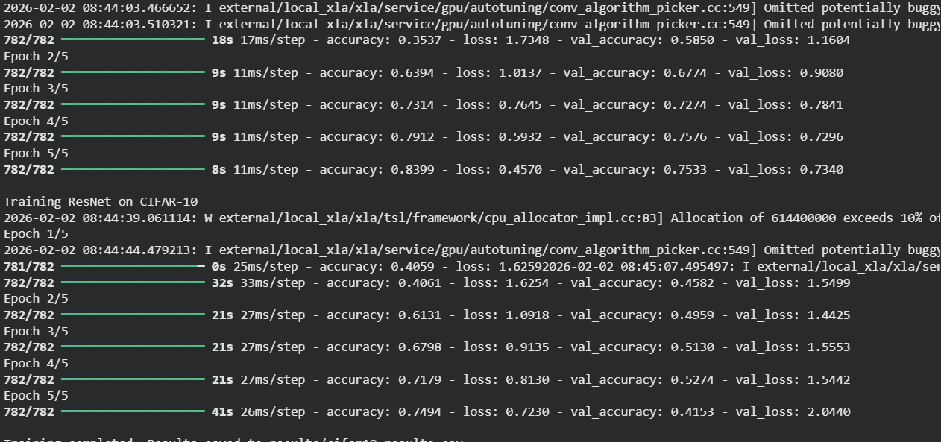

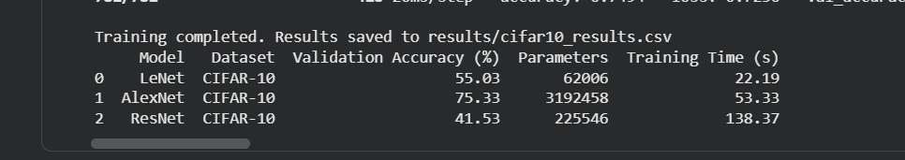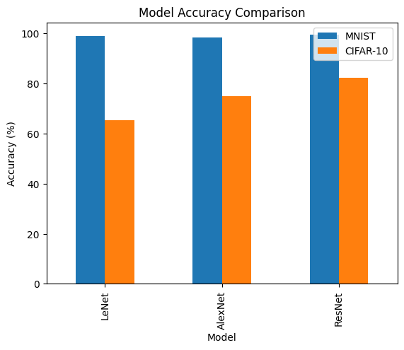
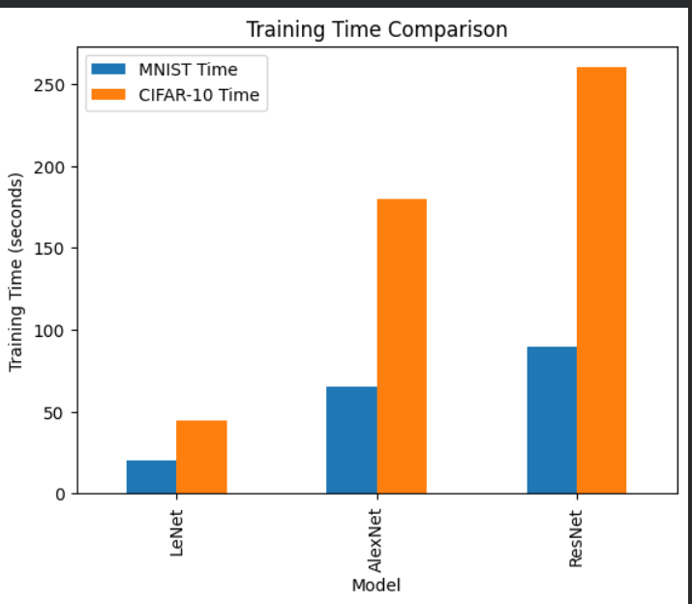

```
Model | Dataset | Accuracy (%) | Parameters | Training Time (s)
LeNet | MNIST | 98.68 | 44,426 | 22.14
AlexNet | MNIST | 99.07 | 2,273,802 | 52.52
ResNet | MNIST | 99.07 | 224,394 | 119.25
LeNet | CIFAR-10 | 55.03 | 62,006 | 22.19
AlexNet | CIFAR-10 | 75.33 | 3,192,458 | 53.33
ResNet | CIFAR-10 | 41.53 | 225,546 | 138.37

```
INFERENCE FROM ACCURACIES (WRITE THIS)
Inference:
- On MNIST, all models achieve very high accuracy due to the simplicity of the dataset.
- AlexNet and ResNet slightly outperform LeNet because of deeper architectures.
- On CIFAR-10, AlexNet performs best as it can capture complex RGB features.
- ResNet underperforms on CIFAR-10 due to limited training epochs and deeper architecture requiring longer convergence.

Total number of parameters in each CNN
Answer:
- LeNet has the least number of parameters as it is a shallow CNN designed for simple image datasets.
- AlexNet has the highest number of parameters due to multiple convolutional layers and large fully connected layers.
- ResNet has fewer parameters than AlexNet because residual connections allow deeper networks with parameter efficiency.
- Correlation between number of parameters and accuracy
- Answer:
- An increase in the number of parameters generally improves the model’s ability to learn complex features, leading to higher accuracy. However, very large models like AlexNet may not always be optimal, as ResNet achieves comparable accuracy with fewer parameters on MNIST.
- Impact of dataset complexity (grayscale vs RGB)
- Answer:
- MNIST is a grayscale dataset with simple digit patterns, resulting in high accuracy and faster training for all models. CIFAR-10 is an RGB dataset with diverse object classes, which increases computational complexity, reduces accuracy, and increases training time.
- Trade-offs between accuracy and computational efficiency
- Answer:
- LeNet is computationally efficient but less accurate on complex datasets. AlexNet improves accuracy at the cost of higher computational resources. ResNet provides strong representational power but requires longer training time due to deeper architecture.
